Evidence portfolio:
Ev1
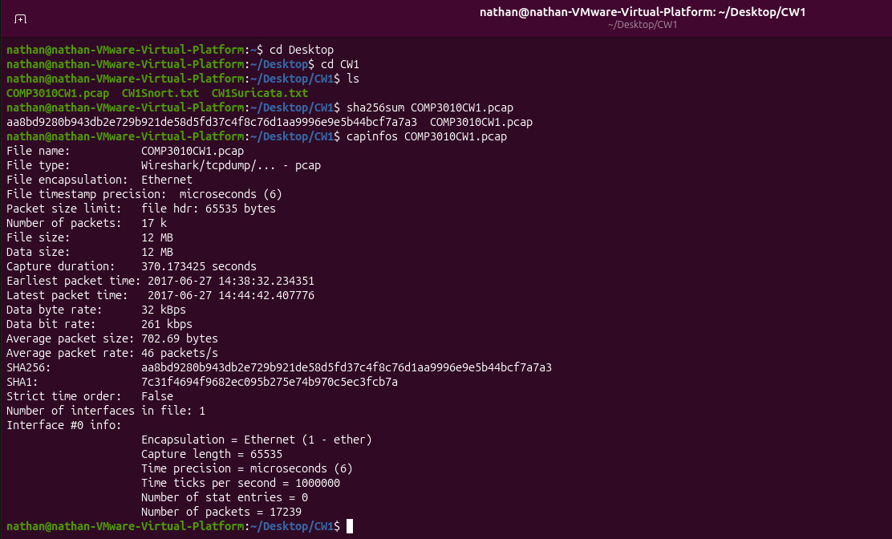
Evidence :
Terminal: sha256sum and capinfos on COMP3010CW1.pcap
What it shows:
Evidence hash aa8bd928….; 17239 packets; capture times (shown in BST)
EV2
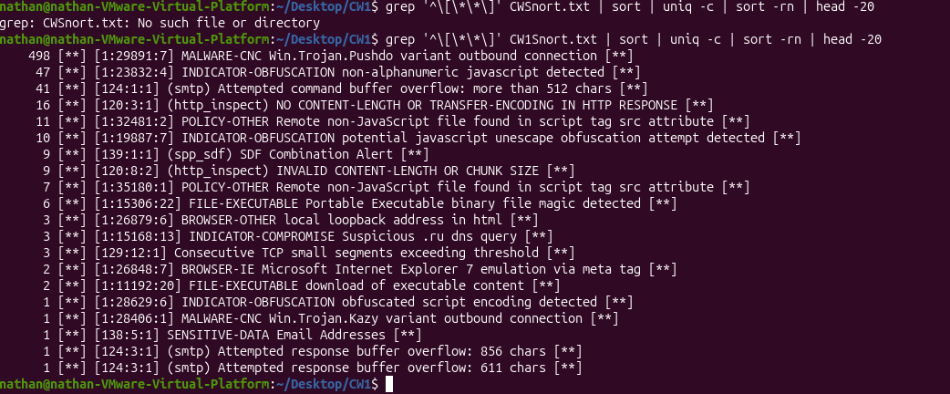
Evidence:
Terminal: Snort alert frequency count
What it shows
Pushdo x498 top alert; obfuscated JavaScript and SMTP alerts
EV3
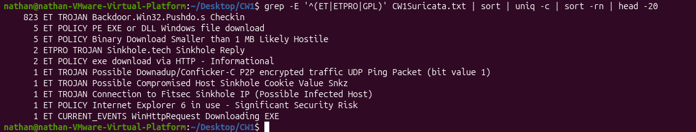
Evidence:
Terminal: Suricata alert frequency count
What it shows
Backdoor.Win32.Pushdo.s Checkin x823; WinHttpRequest Downloading EXE
EV4
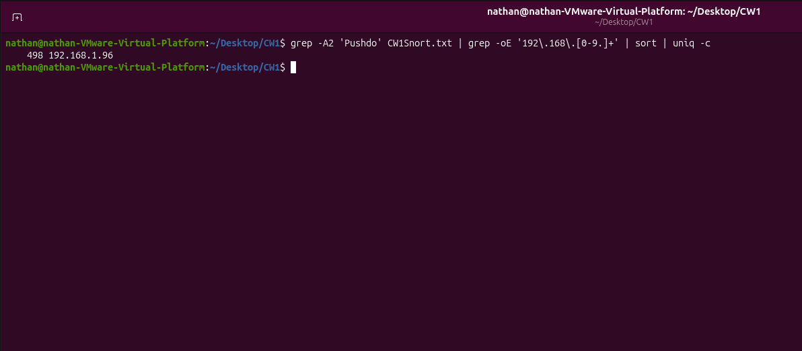
Evidence:
Terminal: grep of Pushdo alerts by internal IP
What it shows
All 498 alerts are linked to 192.168.1.96
EV5
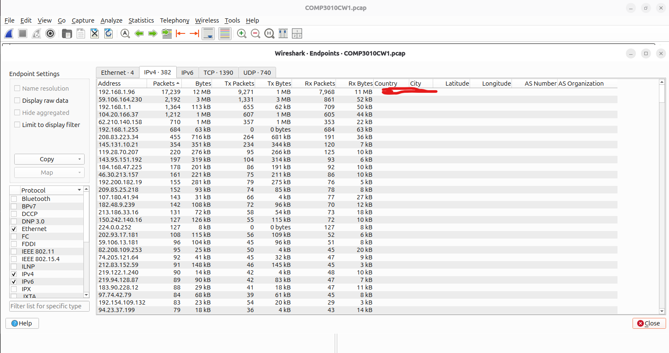
Evidence:
Wireshark Statistics- Endpoints (IPv4)
What it shows
192.168.1.96 is the only active internal host
EV6
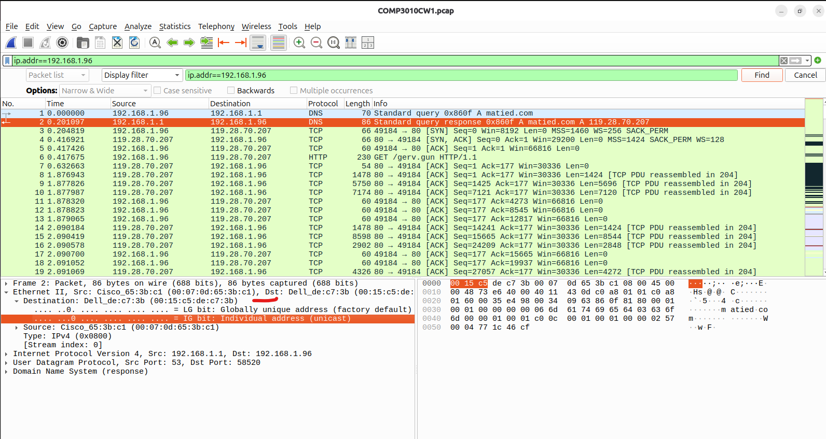
Evidence:
Wireshark frames 1-6 Ethernet header expanded
What it shows
DNS for matied.com, GET /gerv.gun, Dell MAC 00:15:c5:de:c7:3b
EV7
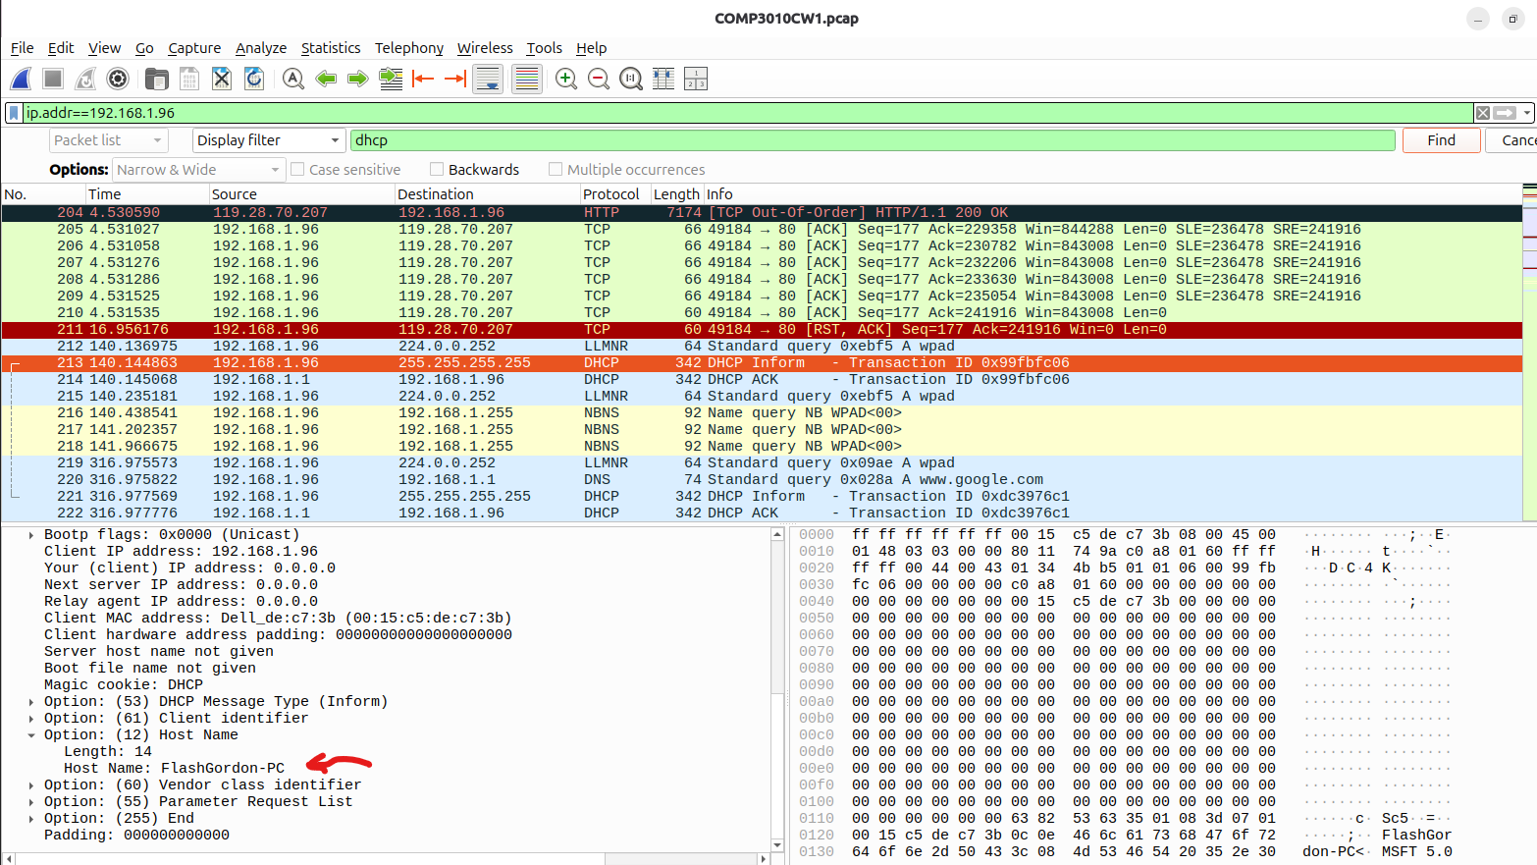
Evidence:
Wireshark DHCP inform, option 12
What it shows
Hostname FlashGordon-PC
EV8
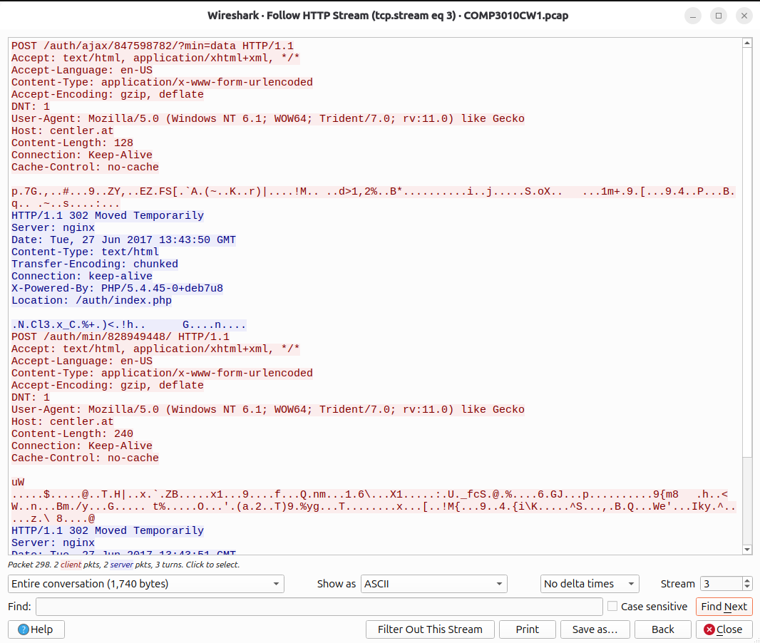
Evidence:
Follow HTTP Stream (tcp.stream eq 3)
What it shows
Encrypted C2 POSTs to centler.at at 13:43:50 GMT
EV9
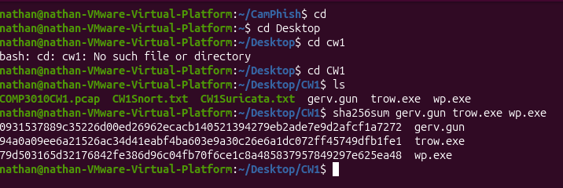
Evidence:
Terminal: sha256sum and file on exported objects
What it shows
Hashes of the three PE32 executables
EV10
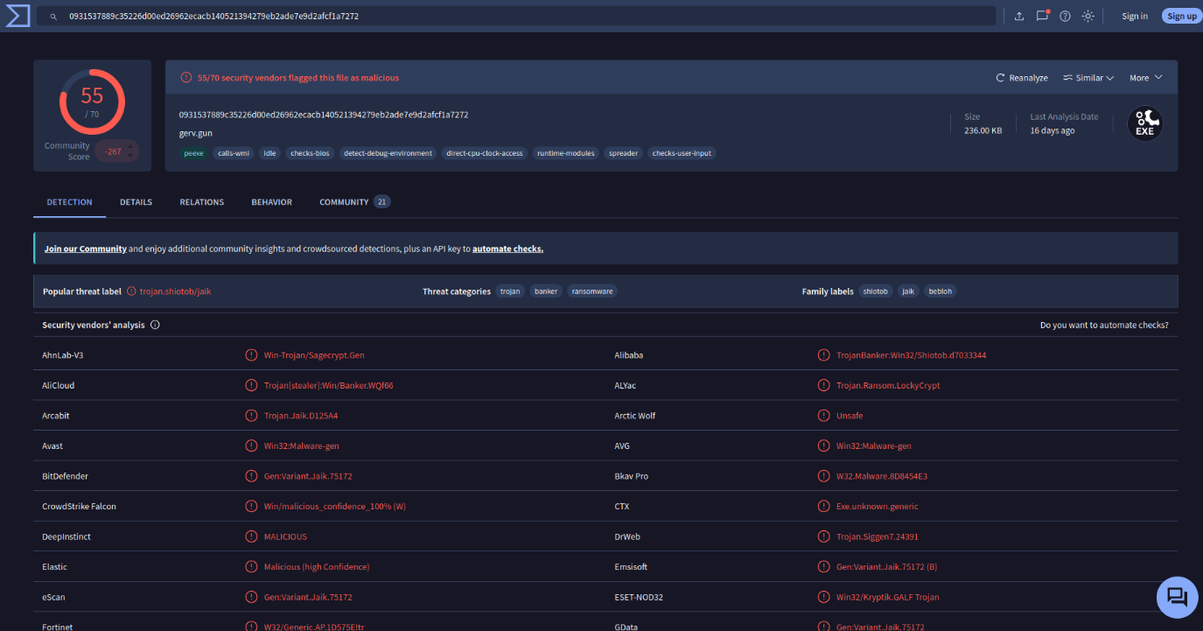
Evidence:
VirusTotal: gerv.gun
What it shows
55/70; Shiotob/Bebloh banker
EV11
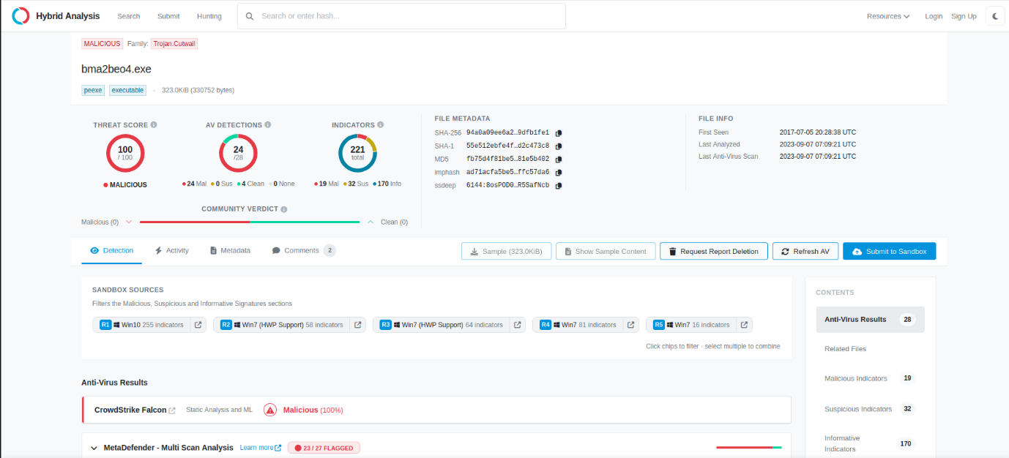
Evidence:
Hybrid Analsis: trow.exe (bma2beo4.exe)
What it shows
100/100; Trojan.Cutwail
EV12
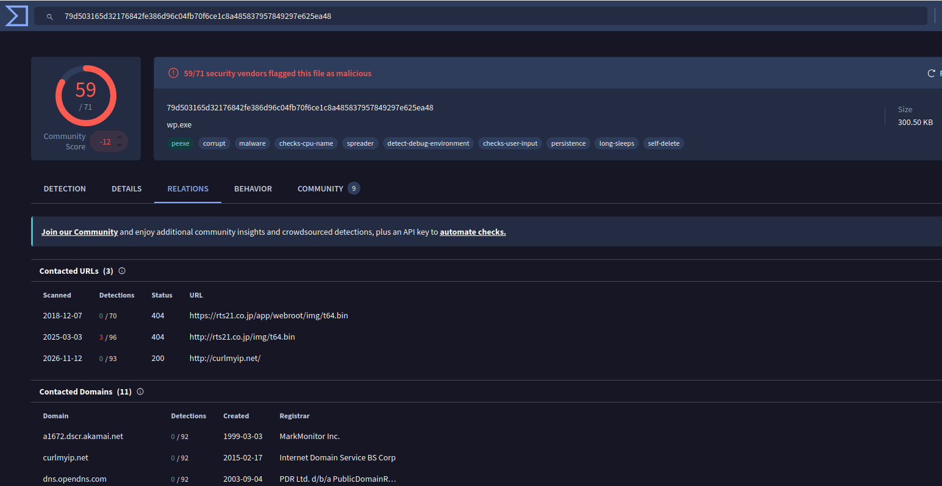
Evidence:
VirusTotal: wp.exe Relations
What it shows
59/71; contacts rts21.co.jp/img/t64.bin

